A000-Eur-Greek-Rooster-Figurine-Terra cotta-550 BCE.

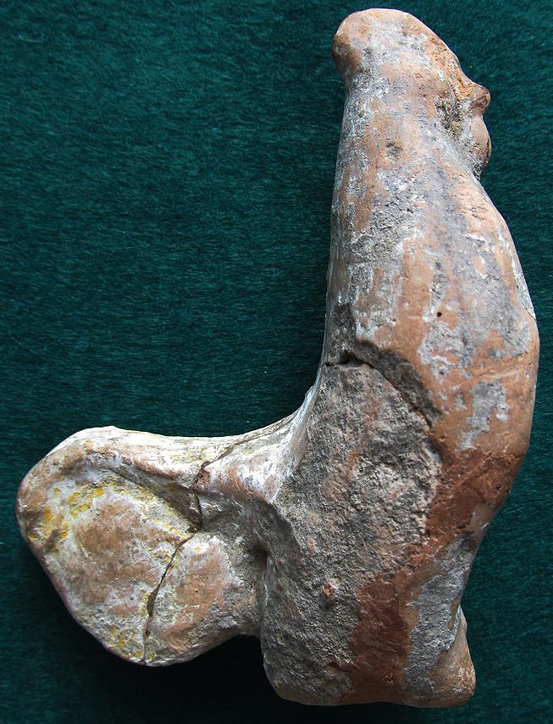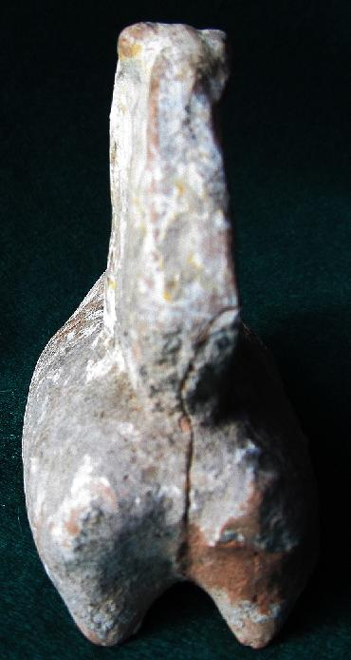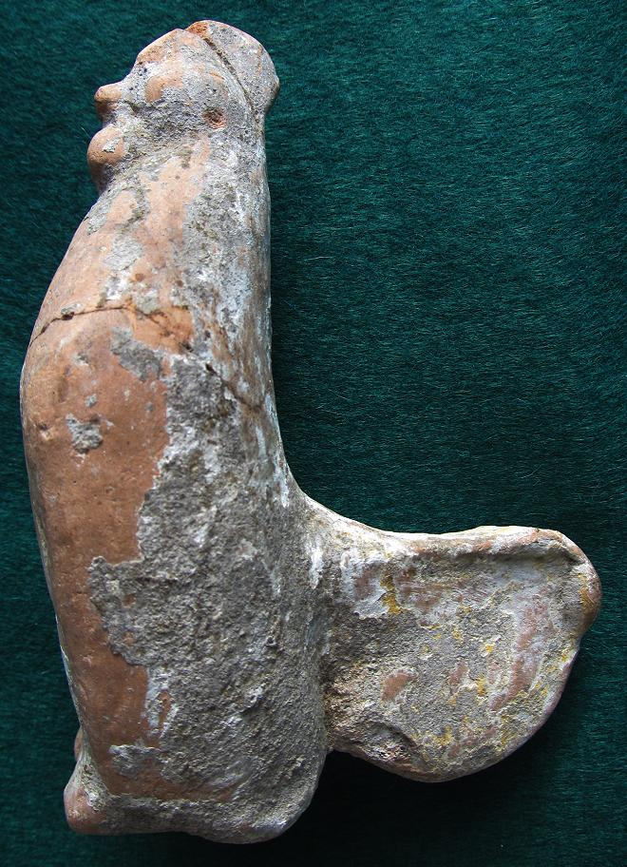

Figs. 1-3. Greek-Rooster-Figurine-Terra cotta-550 BCE.

Case No.:

Accession No.

Formal Label: Greek-Rooster-Figurine-Terra cotta**-5**50 BCE.

**Display Description:**

# This terracotta rooster in erect, strutting posture with prominent comb, wattles and long curving sickle tail feathers conveys all the characteristics of a domesticated red jungle-fowl (Carter 1923). The rooster is a universal solar symbol because its crowing announces the dawn. In Greek tradition Velchanos the Cretan rooster-god was assimilated to Zeus. A rooster was standing beside Leto, pregnant by Zeus, when she gave birth to Apollo and Artemis. Thus the rooster is dedicated to solar gods as well as to lunar goddesses. Moreover, the rooster is the specific attribute of Apollo. A rooster was ritually sacrificed to Asclepios, son of Apollo and god of medicine, because the bird heralded the soul of the dead that it was to guide to the Otherworld. Asclepios is also the god who, by his healing powers, brought the dead back to life on earth. This is precisely the reason why the rooster was also the emblem of Attis, the oriental Sun-God, who died and came to life again. This also explains why the rooster is attributed to Hermes, the messenger who travels the three levels of the cosmos.

Accession Number:

**LC Classification:**

Date or Time Horizon: 550 BCE

Geographical Area: Abai

**Map:**

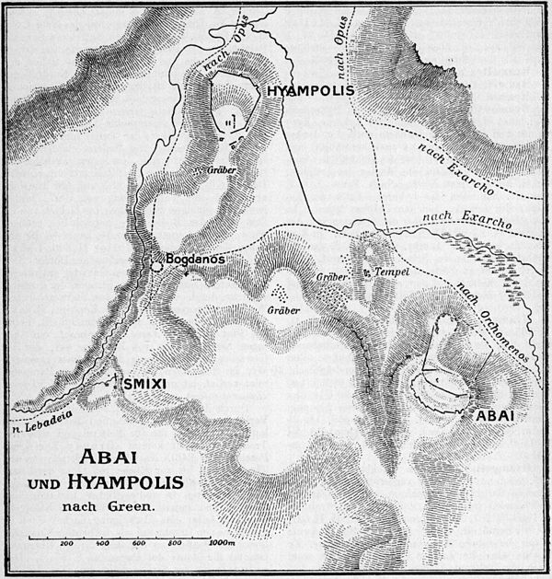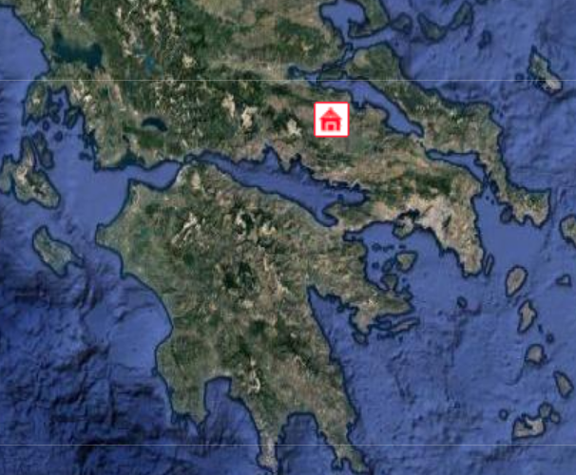

Figs. 4-5. Abai and Hyampolis Sanctuaries of Artemis and Apollo after http://upload.wikimedia.org/wikipedia/commons/thumb/0/05/Pauly-Wissowa_IX,1,_0019_map.jpg/600px-Pauly-Wissowa_IX,1,_0019_map.jpg\

**GPS coordinates:** Latitude: 38.580614N  Longitude: 22.916726E

Cultural Affiliation:

Media:

Dimensions:

Weight:

Condition:

Provenance: The provenance of this rooster appears to be from Abai where one very similarly constructed specimens was excavated in 1896 by the British School at Athens: "Mould made body, handmade legs applied separately. Small circular vent-hole underneath. Clay: reddish yellow. Decoration: white slip. Remnants of red, yellow and black paint on comb, wattle, tail and wings" (see Fig. 6) and another cock figurine with well-defined facial features and a modelled comb and bulging eyes the latter being dated to the early or mid-fifth century BCE (see Fig. 7) (Pisani 2006, no. 104, pl. 32b, no. 107, fig. 28).

# 

# Fig. 6. From Pisani 2006, 104 (T34), pl. 32b. Fig. 7. From Pisani 2006 no. 107, fig. 28. Cm. scale at right

**Discussion:** Abai was an important city near Hyampolis on a tributary of the Kephisos and on the main Orchomenos-Opous road from E Lokris into NE Phokis ([Pausanias. 10.1.1](http://www.perseus.tufts.edu/hopper/text?doc=Paus. 10.1.1&lang=original), 35.1). After two famous Phokian victories over the Thessalians shortly before 480 BCE ([Herodotus. 8.27-28](http://www.perseus.tufts.edu/hopper/text?doc=Hdt. 8.27&lang=original); [Pausanias. 10.1.3-11](http://www.perseus.tufts.edu/hopper/text?doc=Paus. 10.1.3&lang=original)), the spoils and colossal figures were dedicated to the famous oracular shrine of Apollo Abaeus (Ἀβαῖος ) at Abai ([Herodotus 1.46](http://www.perseus.tufts.edu/hopper/text?doc=Hdt. 1.46&lang=original)) which were said to have been consulted by Croesus and Mardonius, among others (Bell 1989: 1) This temple of Apollo Abaeus was destroyed by the Persians in the invasion of Xerxes, and a second time by the Boeotians. It was rebuilt by Hadrian. Perhaps this rooster was part of these dedicated spoils.

**References:**

# References:

Bell, Robert E. 1989. Place-Names in Classical Mythology. [ABC-CLIO](https://en.wikipedia.org/wiki/ABC-CLIO)..

# Carter, H. 1923. "An ostracon depicting a red jungle-fowl the earliest known drawing of the domestic cock." *Journal of Egyptian Archaeology* 9: 1-4.

# Merker, G. 2000. *The sanctuary of Demeter and Koré: terracotta figurines of the Classical, Hellenistic, and Roman periods* (Princeton: American School of Classical Studies at Athens, 2000).

Pisani, Marcella. 2006. The Collection of Terracotta Figurines in the British School at Athens, *The Annual of the British School at Athens,* 101: 269-368.